**Aero2Astro**

**Task 7**

**Report**

**By**

**Anshul Singh**

**Research intern-Inspect**

**PAPER 1**

**A New Vision-Based Method Using Deep Learning for Damage Inspection in Wind Turbine Blades**

This paper aims to introduce a deep learning vision-based approach for detecting certain damages in the face of a wind turbine blade, i.e. by impact of rays, wearing and fractures.

**Methodology:**

Paper focuses on detecting damages of wind turbines using CNN architecture.

In this the damage is classified into 4 classes

1. lightning impact

2. wear

3. Fracture

4. no damage

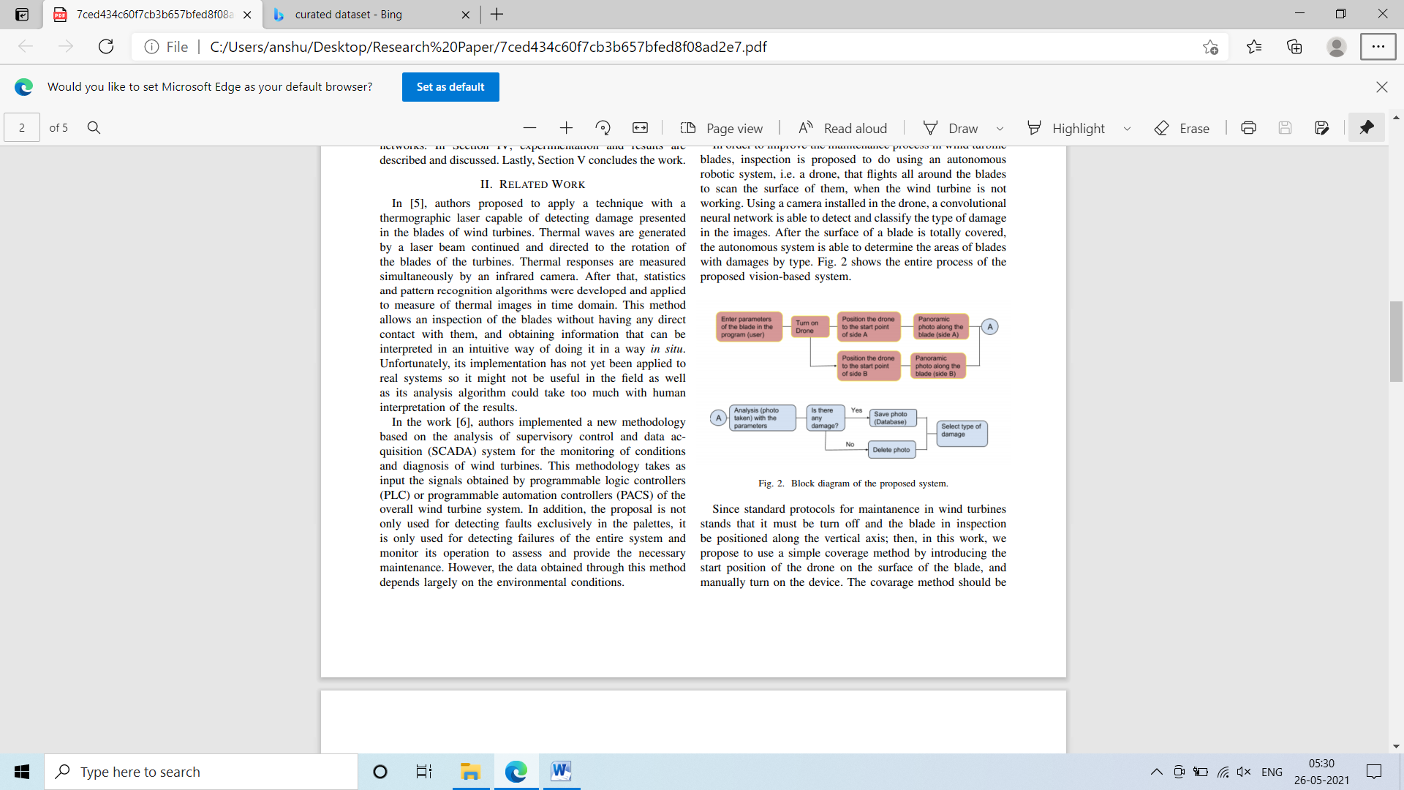

**Algorithm Used:**

1. CNN basic architecture

**Tools Used:**

1. MATLAB

**Dataset:**

They have used handmade data of 78 images of real wind turbine found on public internet.

**Imp Points:**

1. This was just a idea for prototype For real time damage detection they have talked about resolving some issues with this architecture but issues are not discussed in paper
2. For future use they emphasis on transfer learning approach for this task

**Conclusion:**

Although the paper was about a prototype model, it gives a clear idea on the vision based approach for detecting certain images on wind turbine.

**PAPER 2**

**DEFECTNET: MULTI-CLASS FAULT DETECTION ON HIGHLY-IMBALANCED DATASETS**

The paper focus on the imbalanced dataset which we are getting for the task of defect detection. This paper states “The prediction results of traditional networks give a bias toward larger classes, which tend to be the background in the semantic segmentation task.”

**Methodology:**

This paper introduced a new architecture for the defect detection on wind turbine names as defectnet.

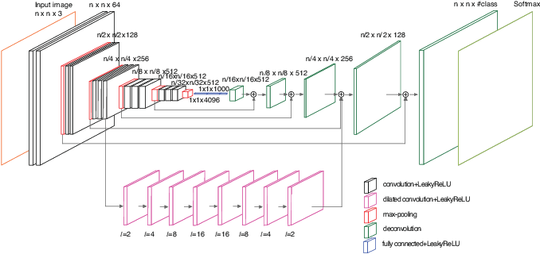

Imp points on Defect net:

* It combines two paths able to detect different target sizes.
* The first path makes use of the VGG-19 architecture and skips layer fusion creating fully convolutional network.
* The second path is for detection of small object they have used **Dilated convolution** on second path.

**Algorithm Used:**

Defectnet (new architecture)

**Dataset:**

Defect dataset which contains 2188 images.

**Some Points:**

1. This paper used reaky relu as activation function as this architecture was facing dying ReLU problem
2. They have used hybrid loss instead of cross entropy loss
3. The paper states that the most common defect that we get in wind turbine is the erosion.
4. The defects are classified in 9 classes in this paper.
5. The architecture gives a good accuracy on 9 classes which is better than other architectures at that time.

**Conclusion:**

This paper gives a very good idea to detect big and small objects. This focuses separately for big visual defects and for detecting small cracks. The defect net architecture was better than any other technique for this task at that time.

**PAPER 3**

**Mechanism and system design ofMAV(Micro Aerial Vehicle)-type wall-climbing robot for inspection of wind blades and non-flat surface**

The objective of this paper is to create a MAV for visual inspection of defects of wind turbines and towers.

For the inspection pov this paper states inspection in two ways

1. Macro inspection
2. Micro Inspection

This paper focuses more on the making of MAV instead of inspection task

This paper gives a very basic ideas on the defects in the wind turbines.

**Conclusion:**

This paper focues more on the making of MAV. Its does not cover how the inspection task is going to be done in depth. This paper is not much useful for our task.

**PAPER 4**

**Image-based Damage Recognition of Wind Turbine Blades**

The papers objective is to recognize damage in the wind turbine by the visual data(images).

**Methodology:**

This paper introduced a architecture. The process of damage detection is recognized by two stages

1. Deep feature extracting learning stage use for extracting deep feature of the blade images
2. Second stage is pattern learning stage.

Then SVM is trained on the deep features to extract the damage type.

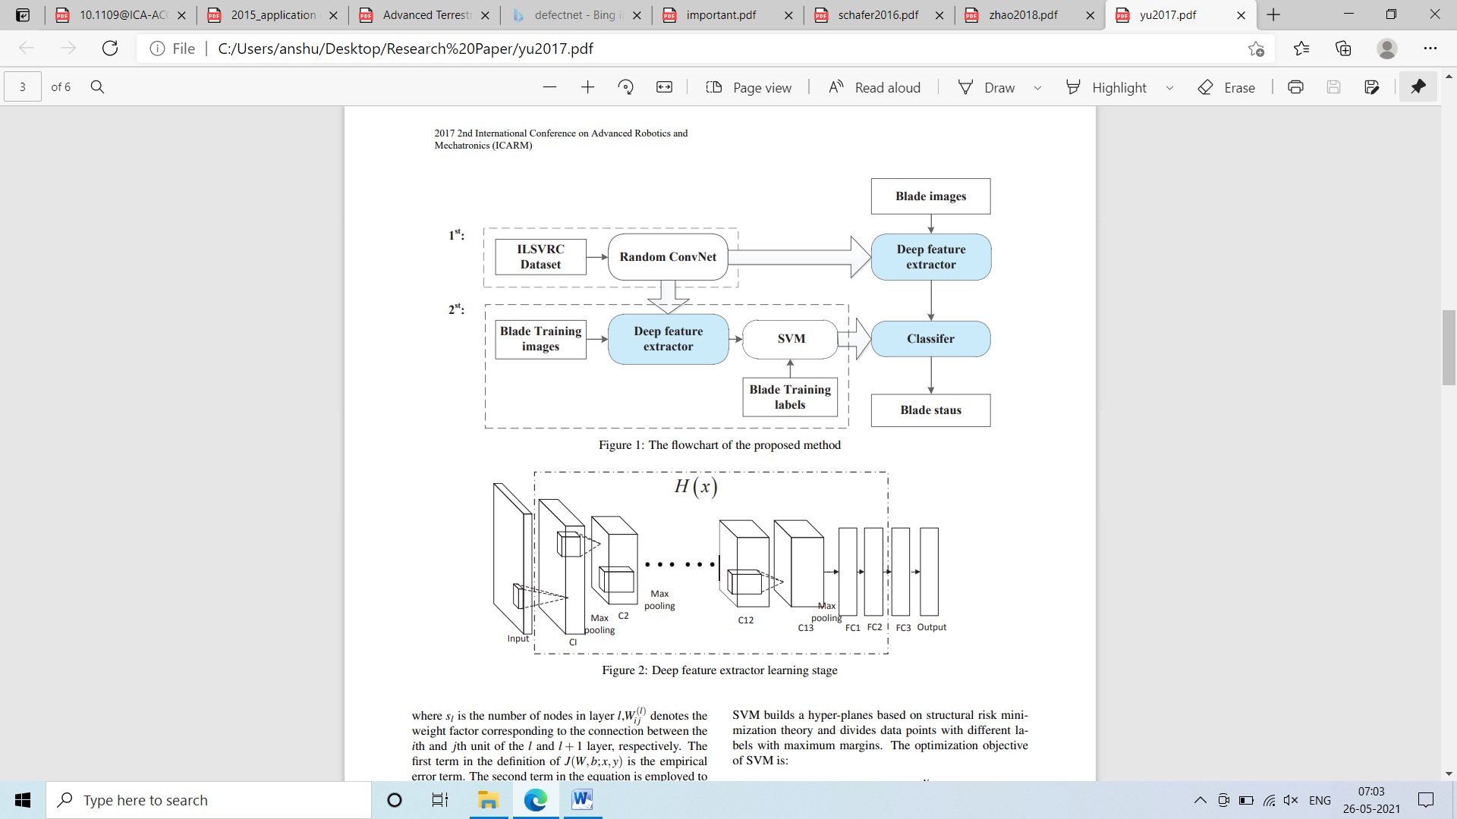

**Dataset :**

In this paper ILSVRC dataset is used.

They have used 3 status for the wind tubine defects they are trailing edge damage, delamination and normal status.

**Some imp points:**

1. They have used relu as the activation function.
2. They have used SVM for the classification.
3. The convnet architecture which is used is very basic

**Conclusion**

This paper gives a very nice idea on the fault detection on wind turbine. Separating the task of fault detection in two step make it more precise.

**PAPER 5**

**A UAV-BASED CRACK INSPECTION SYSTEM FOR CONCRETE BRIDGE MONITORING**

The main objective of this paper is to detect cracks in the bridges using aerial insapection. This paper is included by me because is think it can give us some ideas about the crack detection which we can apply on the wind turbines too.

**Methodology:**

They have used panorama technique. Cracks will be detected by a fast structured learning framework based on random decision forests.

The crack detection problem is to label each pixel with a binary variable indicating whether the pixel contains an edge point or not.

They have used crack detection in following steps:

1. Camera Calibration
2. Motion blur removal
3. Image stitching
4. Edge detection
5. Morphological operation
6. Crack measurement

**Dataset:**

These entire tasks are done for bridge so data is not useful for us. They have make their dataset of own.

**Some points**

1. They have compared their method with canny method
2. They have label each pixel with a binary variable indicating whether the pixel contains an edge point or not.

**Conclusion**

This data talks about the crack detection but they did not talk about any particular method that can be helpful for us. Some points can be learnt from this about the crack detection.

**PAPER 6**

**Deep-learning-based Autonomous Navigation Approach for UAV Transmission Line Inspection**

This paper focus on detecting the transmission tower instead of any defect detection techniques

**Methodology:**

**The paper has used techniques like faster RCNN, SSD, and YOLO for the detection of the tower itself.**

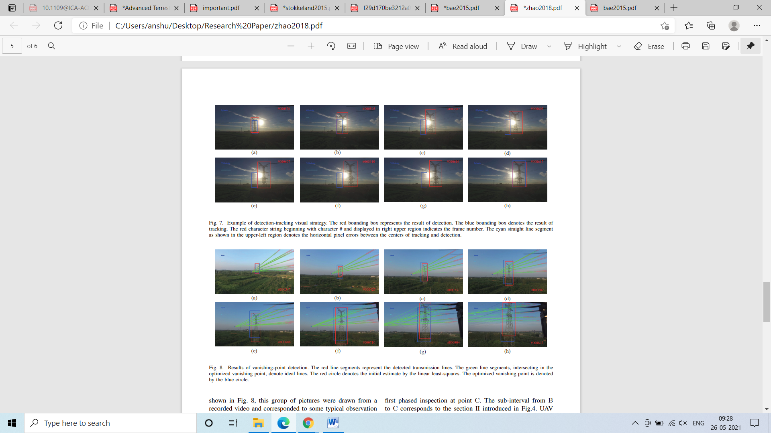

**Some points:**

1. This paper uses the object detection techniques like faster rcnn, yolo which can be helpful for our task too
2. This paper gives a idea about the navigation of UAV for inspection.

**Conclusion**

We can get the idea how to take images using UAV from this but for the task of defect detection it is not so much useful

**PAPER 7**

**Advanced Terrestrial and Aerial Monitoring and Inspection System for Critical Infrastructures**

This paper focuses on making a intelligent system for the inspection of infrastructure.

**Methodology:**

* Video streaming data processing is performed first
* Static images from video streaming processing are done later.
* On this images Deep learning model is used to find defects in the infrastructure.
* Segmentation technique is used

**Algorithm Used:**

MLP neural network

C**onclusion**

Segmentation technique is used which can be helpful for our task apart from this it uses MLP architecture which does not give a good accuracy too. SO no such information is gained from this paper.

**PAPER 8**

**Insulator Detection in Aerial Images Based on Faster Regions with Convolutional Neural Network**

This paper focus on detecting insulator and fault in insulator of a transmission tower.

**Methodology:**

1.RPN is used to get the particular region

2.Fast RCNN is trained for this task

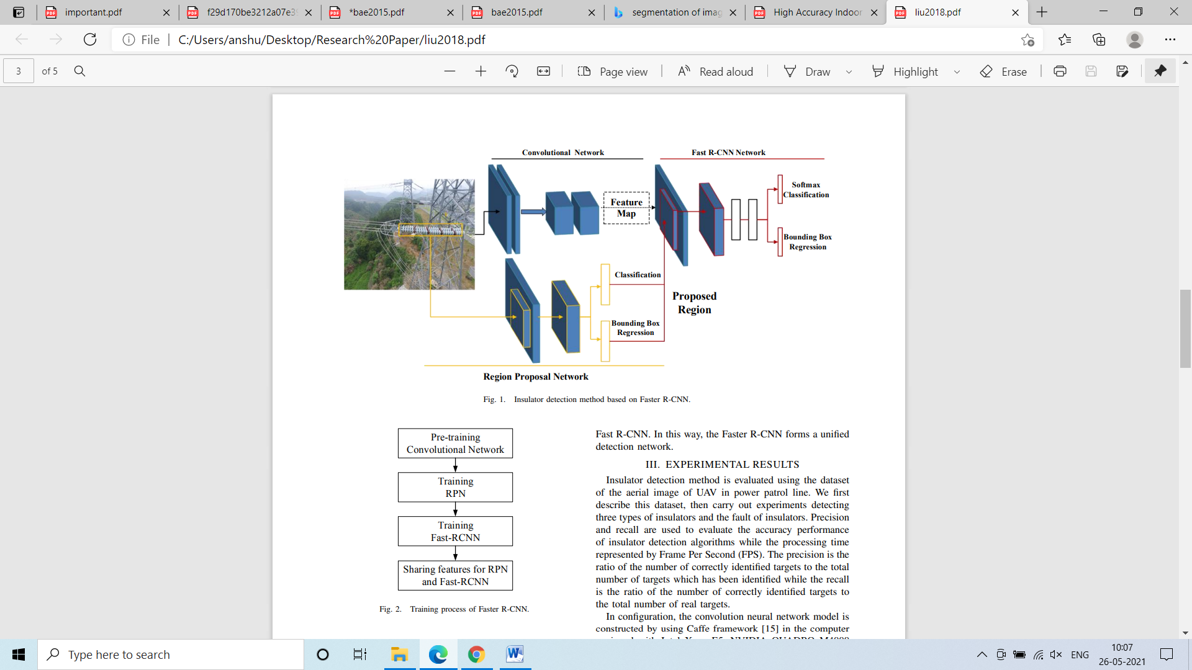

**Some points:**

The faults are divided into two category :

1. Insulator Type
2. Missing caps

**Performance**

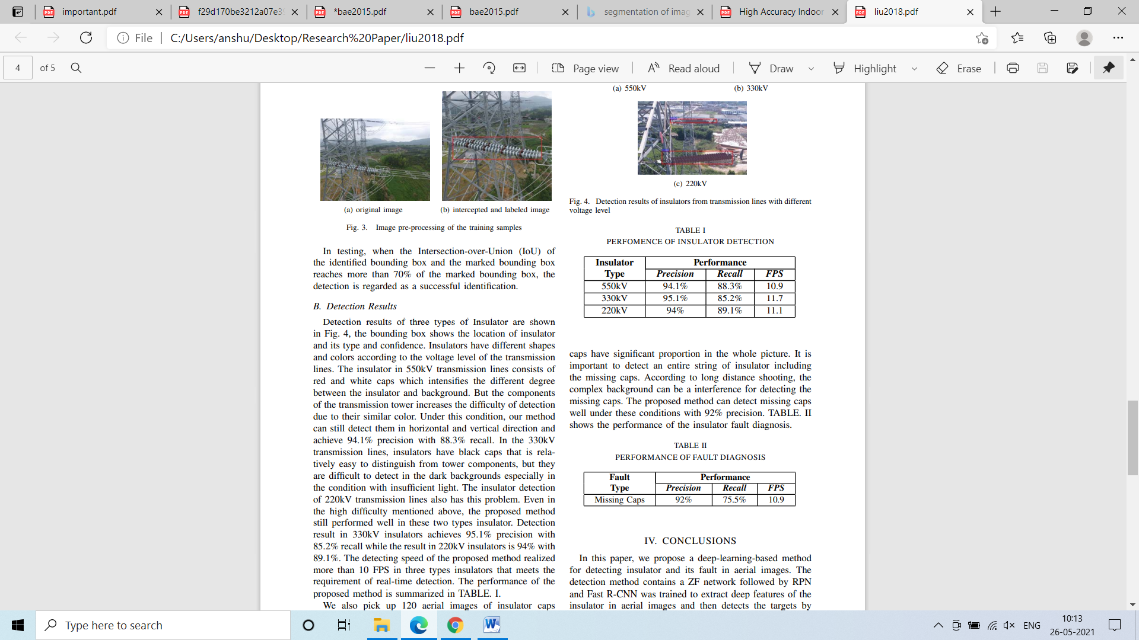



**Conclusion:**

The accuracy and speed meet the partial requirements of the real time application using Fast RCNN but making this on faster RCNN will improve the fault detection task